Unlocking Insights into the Global Air Transportation Network with Tableau.

**INTRODUCTION**

1.1 Overview

This Global Air Transportation Network dataset is a comprehensive collection of information on airports, airlines and their routes. It contains information such as names, cities, countries, codes (IATA and ICAO) longitudes, latitudes and altitudes of airports across the world with detailed time zone and daylight saving time data. Additionally, this includes information about airlines including their IDs, name aliases, IATA and ICAO codes, callsigns country of origin and active/inactive status. Similarly, it also covers route details such as airline sources to destination airports along with essential details like codeshare stakeholder if any stops required during this journey along with the type of aircraft being used for that particular journey. This dataset has been compiled through meticulous labor by researchers all over the world to give you a comprehensive detail into air transportation networks from around the globe.

**Technical Architecture:**



1.2 Purpose

The air transport network is a global system of flight operations, connecting thousands of different destinations through both direct services and serv- ices via major hub airports. Air transport provides benefits by allowing people and goods to travel from A to B. Transport reduces the rigours of immobility of certain factors of production. Mobility of labour and capital increases with the development of transport. An efficient network of transport services encourages the movement of people from one place to another.

**PROBLEM DEFINITION &DESIGN THINKING**

2.1 Empathy Map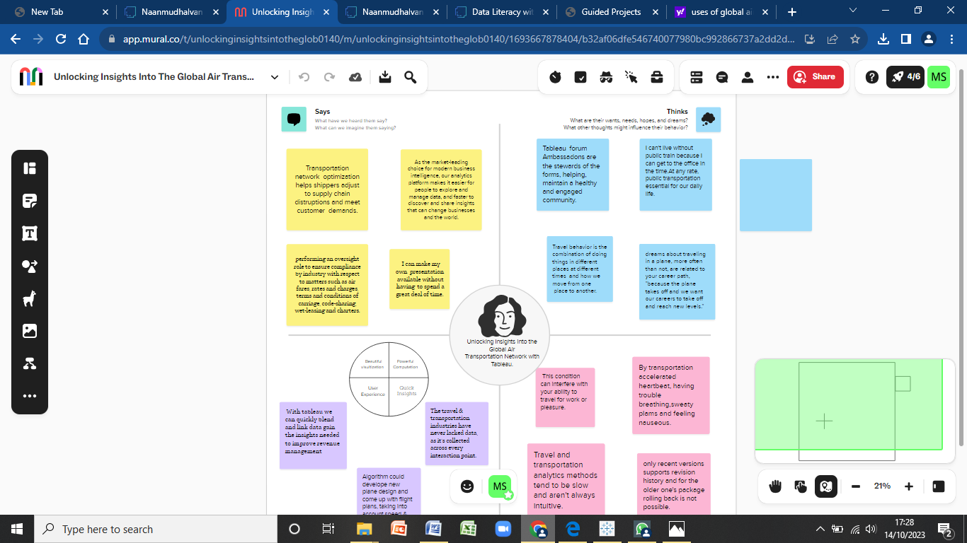

2.2 Ideation &Brainstorming Map

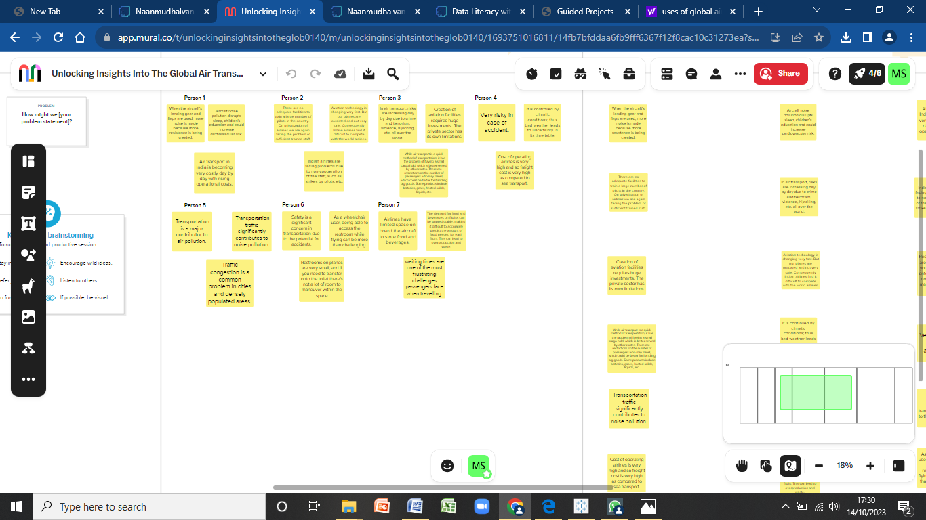

**RESULT**

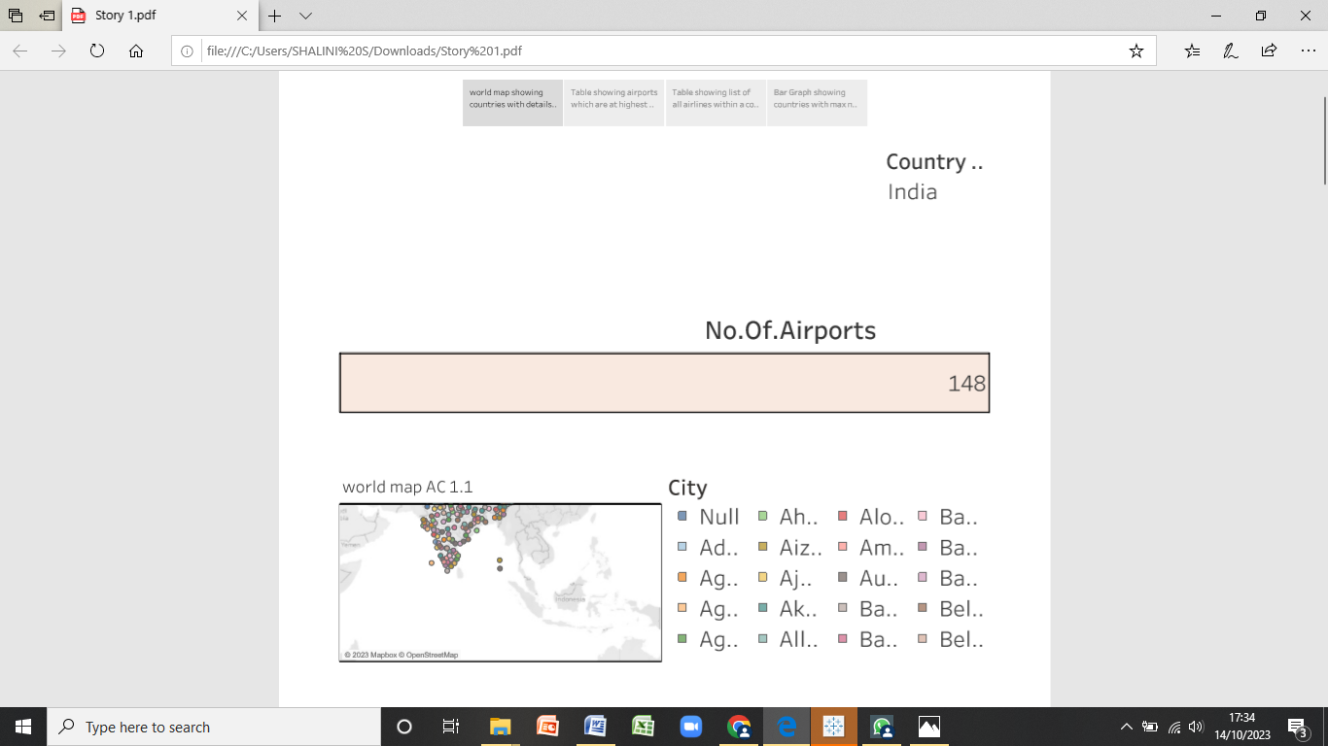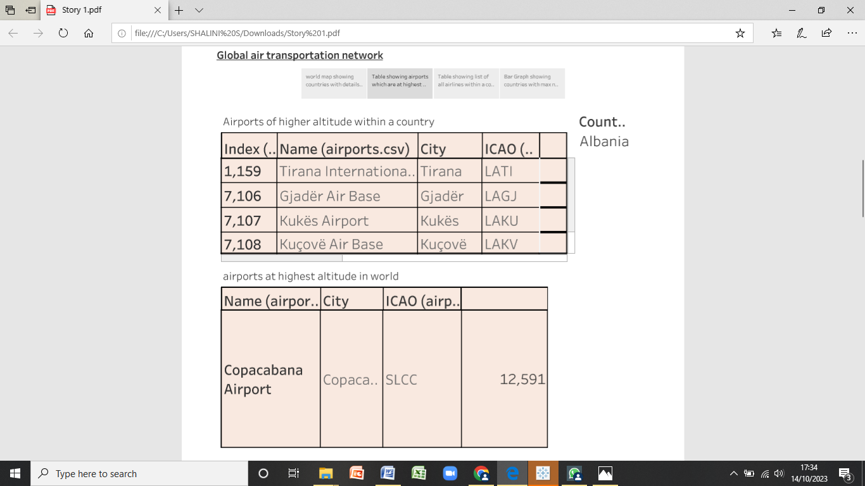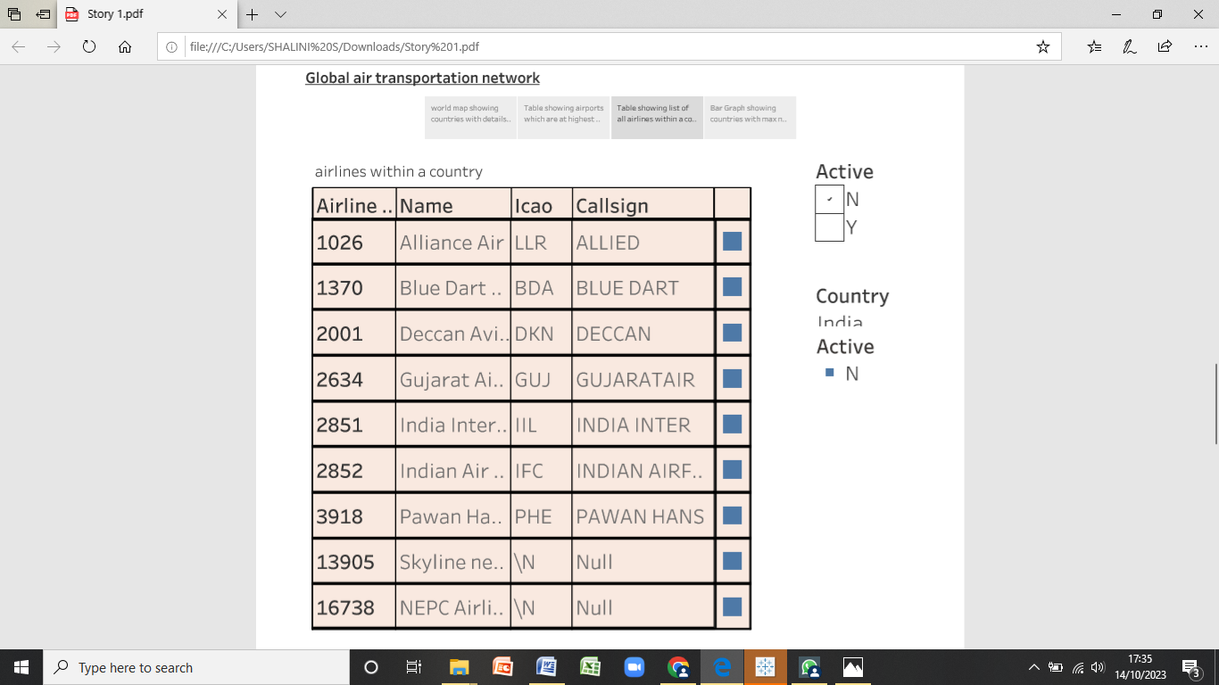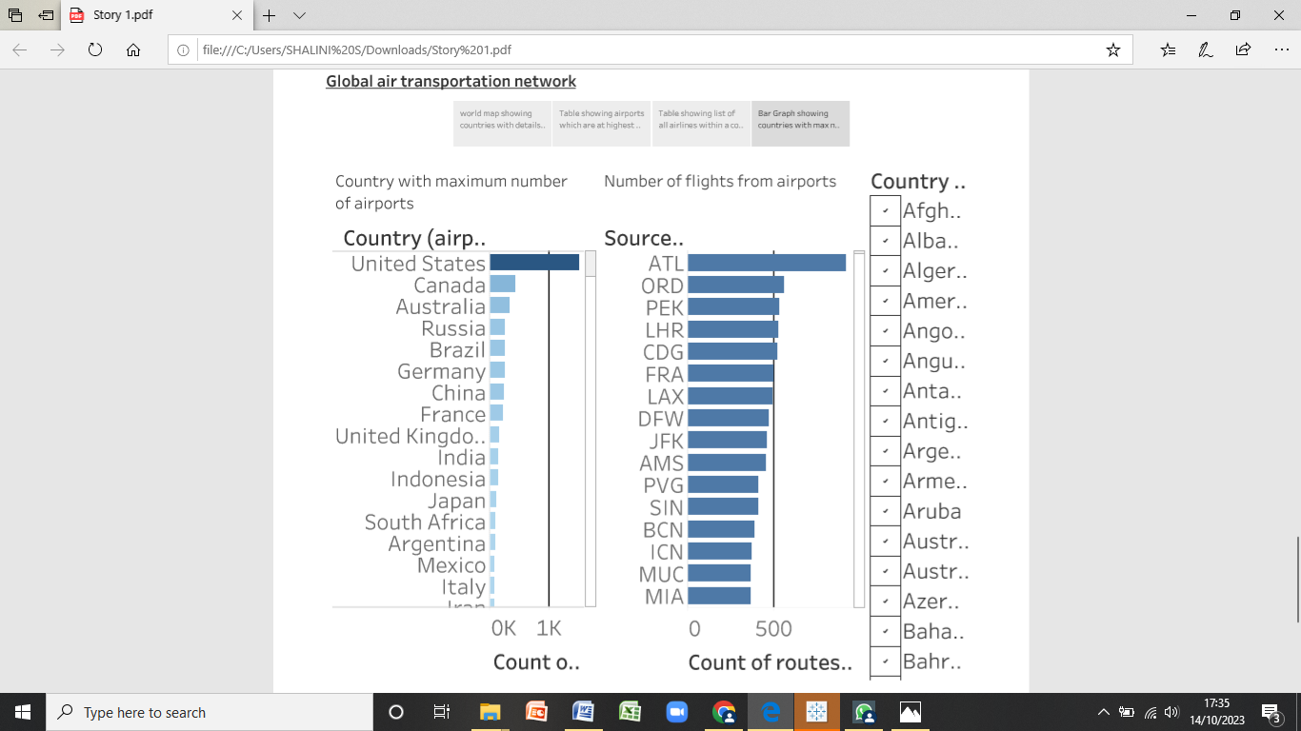

**ADVANTAGES & DISADVANTAGES**

Adavantages:

It is very useful and helpful to find the routes .We can say with in fraction of seconds how many airports are avaible in a country. Airforce service is essential to any nation. The air force provides a much quicker and easier approach to reach the adversary and neutralize their wicked intents with less collateral damage in modern conflicts that are not just fought on land borders. It plays a very important role in saving lives and giving people extra assistance in difficult times during natural calamities like earthquakes, floods, etc. Air transport can be used to convey individuals and goods to locations that are inaccessible by other transport methods.

Disadvantages:

This is significantly more costly for its services than land, rail, and water transportation. If passengers' financial situation could be better, they cannot travel frequently. Even while air travel offers affordable economy class tickets and expensive business class seats, it still costs more than other forms of transportation. Cargo is subject to the same rules. Although it offers a faster level of service than other options, which is fantastic for trading air services, the costs are high and specific permission is required.While air transport is a quick method of transportation, it has the problem of having a small cargo hold, which is better served by other routes. There are restrictions on the number of passengers who may travel, which could be better for handling big goods. Some products include batteries, gases, heated solids, liquids, etc.

**APPLICATION**

Airlines use databases for storing passenger information when tickets are booked and when passengers check-in at the airport. One major shift has been the need for an Airport Operational Database AODB. This database helps airports keep track of a wide range of data and information, from flight schedules and aircraft performance to passenger management and baggage tracking. Information technology system supports a lot of functions including reservation management, ticketing, and inventory management. The Airline Company has a number of branches and distributors over the globe.

**CONCLUSION**

In conclusion, we can find very fast with in fraction of seconds how many airports are there in any country and aslo we can findwhich is the highest airlines and aslo maximum number of aiports, air freight is a fast, flexible, and efficient shipping method that provides businesses with numerous benefits, including speed, flexibility, efficiency, and reduced risk of damage or loss.The Indian aviation industry has undergone significant developments and growth in recent years. The expansion of regional connectivity, emergence of low-cost carriers, increased investment in infrastructure, and adoption of technological advancements have all contributed to the growth of the industry. The worldwide air transportation network is a critical infrastructure with high impact on mobility, trade and economy. Another examples are the air transport systems of a country or a country's own air transport company.

**FUTURE SCOPE**

The industry has a number of domestic and international airlines, as well as a large network of airports. The future of the aviation industry in India is likely to see continued growth and expansion, driven by factors such as a growing middle class, increased tourism, and government policies supporting the industry.This number has been envisaged to go up to 190-200 by 2040. The field of aviation management offers opportunities to work in the capacity of cabin crew, ground staff, in retail management, hospitality, and travel management, all of which offer a wide scope to explore the world. To make air travel the seamless, efficient industry it strives to become, digital technologies will have to be integrated. Security is always front of mind. The airport of 2030 will use biometric identification to speed travellers through passport control and security.